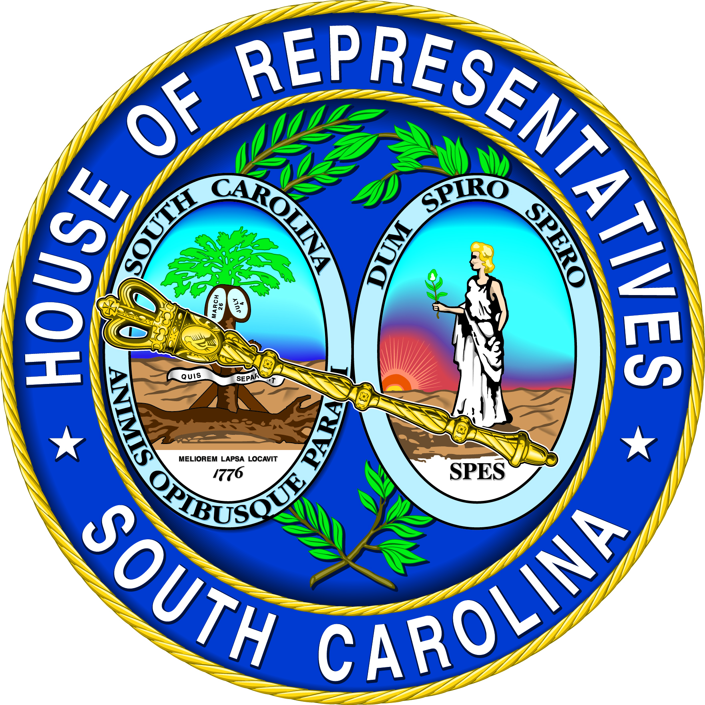 | Rep. Rosalyn Henderson-Myers  SC House District #31 - Spartanburg County  530-C Blatt Building  Columbia, SC 29201  803-212-6965 | 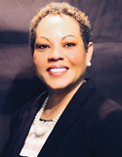

House Floor Review
March 9 - 11, 2026

H. 3368 Tax Conformity
The House approved and sent the Senate H. 3368, a bill to provide for tax conformity. The legislation updates references in state statutes to the federal Internal Revenue Code and coordinates South Carolina’s income tax provisions with federal tax provisions. The legislation allows South Carolinians to take advantage of various benefits in state income tax provisions that have been enacted at the federal level in the “One Big Beautiful Bill” such as income tax exemptions for overtime pay and tips and tax deductions for interest on loans for American-made automobiles.

H. 4216 State Income Tax Reform and Elimination
The House concurred in Senate amendments to H. 4216, legislation allowing for state income tax reform and elimination, and enrolled the bill for ratification. A tax reduction schedule is established that allows for the gradual lowering of the top marginal income tax rate and the ultimate elimination of South Carolina’s income tax. The bill locks in roughly $300 million in immediate tax cuts starting in 2027. Moreover, about 44 per cent of filers with income paid zero state income tax, which shifts the entire burden onto tax-paying families. No more.

Under the legislation, the state’s current three-tiered system is collapsed into two income tax brackets, with the lower bracket of income up to $30,000 taxed at a rate of 1.99 per cent and the higher bracket for income above $30,000 taxed at a rate of 5.21 per cent, lowered from the current 6 per cent tax rate for the highest income level. The legislation establishes a schedule for further reducing the top marginal tax rate in years when revenue growth targets are met. In years when individual income tax revenue collections surpass a 5 per cent minimum threshold, a portion of the surplus revenue is devoted to tax relief until the top marginal rate reaches 1.99 per cent, achieving a flat rate. This single flat rate of 1.99 per cent is then subjected to the tax relief schedule so that it is lowered in years when the revenue targets are met until the rate reaches zero, eliminating the state’s income tax altogether. Additionally, the legislation decouples South Carolina from federal income tax provisions so that state provisions would no longer mirror the standard deductions and itemized deductions allowed in the federal tax code. State income tax exemptions and credits are retained and can be used as the tax relief schedule is followed for phasing out state income taxes. The state’s earned income tax credit is capped at two hundred dollars. Provisions are made for a South Carolina Income Adjusted Deduction (SCIAD).

H. 5126 General Appropriation Bill
H. 5127 Capital Reserve Fund
The House of Representatives amended, approved, and sent the Senate H. 5126, the General Appropriation Bill and H. 5127, the joint resolution making appropriations from the Capital Reserve Fund, which together comprise the $16 billion Fiscal Year 2026-2027 State Government Budget. After $825 million is transferred to the Tax Relief Trust Fund that provides for the residential property tax caps, $14 billion in recurring general fund revenue is available for appropriation. The budget’s $1.7 billion in nonrecurring revenue includes $387 million in Capital Reserve Funds, $726 million in the Contingency Reserve Fund, and $601 million in Fiscal Year 2025-2026 projected surplus. Additionally, a total of $533 million in Education Lottery funds is available for appropriation and a total of $1.5 billion in Education Improvement Act funds, $1.4 billion in recurring and $84 million in nonrecurring revenue.

In keeping with the “Comprehensive Tax Cut Act of 2022,” $119 million in recurring revenue is used to advance the tax relief schedule, allowing the highest income tax bracket to be lowered from 6.0 per cent to 5.21 per cent.

$130 million in recurring revenue is devoted to property tax relief.

The Department of Transportation is afforded $49 million in recurring funds, $60 million in nonrecurring funds, and $140 million in Capital Reserve funds for repairing and replacing the state’s bridges, $125 million in nonrecurring funds to accelerate its Interstate Highway projects, and $25 million in nonrecurring funds for its road buyback program.

$100 million in nonrecurring funds is devoted to the state’s County Transportation Committees to accelerate their local road project schedules.

The Division of Aeronautics receives $10 million in recurring funds and $60 million in nonrecurring funds for airport development.

$73 million is provided from the Capital Reserve Fund to the South Carolina Emergency Management Division for state match in federally declared disasters relief.

Full funding is provided for the state financial reserve accounts used to cope with revenue shortfalls.

$67 million in recurring revenue is used to provide a 2 per cent state employee pay increase.

$34 million in recurring funds is used to address rising costs in the state's health insurance plan with no increases in monthly premium costs for employees and retirees.

$90 million in State Aid to Classrooms allows for a $2,000 teacher pay increase. The minimum starting salary for teachers is increased to $50,500.

The total for State Aid to Classrooms in the budget represents an average per pupil appropriation of $6,023. The average total is $20,574 per pupil when federal, state, and local funding commitments are factored together.

$23 million in recurring funds is provided for the Education Scholarship Trust Fund to allow for more grants that enhance school choice opportunities.

$75 million in nonrecurring funds is provided for rural and charter school capital needs.

$20 million in nonrecurring Education Improvement Act funds is appropriated for school safety grants.

The Department of Education is authorized to use $2 million of the funds appropriated for school safety to assist high-needs schools and school districts with cardiac emergency response plans that may include purchases of defibrillators and CPR training.

$4 million in recurring Education Improvement Act funds and $34 million in nonrecurring EIA funds is used for instructional materials.

$8.2 million recurring EIA funds goes to instructional support for school districts.

$15 million in recurring EIA revenue funds Summer Reading Camps.

The Child Early Reading Development Program is afforded $9.9 million in nonrecurring EIA funds for CERDEP expansion in private centers.

$6 million in recurring EIA revenue is devoted to the Imagination Library.

$1 million in nonrecurring Education Improvement Act is appropriated for a Teaching Transformation Pilot Program.

$5 million in recurring EIA revenue is allocated for teacher strategic compensation.

$2 million in recurring funds and $28 million in nonrecurring funds is allocated for purchasing and leasing school buses.

$8.7 million in recurring Education Improvement Act funds goes to the Child Nutrition Program.

$82 million recurring EIA funds is provided for career and technology education.

The budget includes over $59 million in recurring revenue to support higher education statewide and over $371 million for infrastructure improvements at the state’s institutions of higher learning.

The budget includes the Funding Innovation and Realignment for In-demand Skills and Talent, SC FIRST, initiative in which additional recurring funding is distributed among the state’s institutions of higher learning that must be used exclusively in support of programs that instruct undergraduate students in the critical workforce disciplines of Science, Technology, Engineering, and Mathematics (STEM); as well as education and training, government and public administration, health science, and human services. In order to retain these appropriations, the institutions must comply with provisions for freezing in-state tuition and mandatory fees for undergraduates during the 2026-2027 academic year. Institutions must identify and suspend new admissions for at least fifty percent of all academic programs that operate at a financial loss for at least four academic years. Each institution is required to submit an annual report detailing the programs discontinued or consolidated, the cost savings achieved, and the programmatic enhancements implemented under this initiative

The Medical University of South Carolina receives $175 million from the Capital Reserve Fund for its Comprehensive Cancer Hospital.

$10 million in Education Lottery funds is provided to the Commission on Higher Education for its Nursing Initiative budget:
Full funding is provided through the Education Lottery for the LIFE, HOPE, and Palmetto Fellows higher education scholarship programs.

The Commission on Higher Education is afforded $80 million in lottery funds for need-based grants.

The Higher Education Tuition Grant Commission is allocated $20 million in lottery funds.

$3.6 million in lottery unclaimed prize funds is appropriated for College Transition Program scholarships through the CHE.

$53 million from the Education Lottery is devoted to tuition assistance through the Commission on Higher Education and the Board of Technical and Comprehensive Education.

The Board of Technical and Comprehensive Education is afforded $52 million in nonrecurring funds, $25 million in Education Lottery funds, and $18 million in unclaimed prize funds for SC Workforce Industry Needs scholarships that help provide full tuition at technical colleges for SC WINS recipients seeking degrees in industry sectors with critical workforce needs. $6.5 million in recurring funds is devoted to equipment for high demand job skills training.

$5 million in lottery funds is allocated to the Ready SC Program which provides worker training at the state’s technical colleges that is customized to the needs of new and expanding business and industry.

The Department of Employment and Workforce is afforded $1 million in nonrecurring funds for the Graduation Alliance.

The Department of Commerce receives $1 million in recurring funds for the Closing Fund it uses to facilitate business investment and $1 million in recurring funds for site readiness through LocateSC to address business and industry needs.

The Rural Infrastructure Fund is appropriated $1 million in recurring funds and $7.3 million in nonrecurring funds. $1 million in recurring funds and $7.2 million in nonrecurring funds is included for the Statewide Water and Sewer Fund.

The Department of Agriculture receives $5 million in nonrecurring funds for its Growing Agribusiness Fund, $200,000 in recurring funds for SC seafood marketing, and $750,000 in nonrecurring funds for microbiological testing equipment.

Clemson University PSA is afforded $1 million in recurring funds for the Natural Resources Utilization and Planning Institute.

SC State University PSA receives $500,000 in recurring funds for agribusiness development, $400,000 in recurring funds for agriculture innovation research, and $6 million in nonrecurring funds for the 422 Crossroads Agriculture Center.

The Department of Parks, Recreation and Tourism receives $275,000 in recurring funds and $9 million in nonrecurring funds for destination specific tourism marketing grants, $9.4 million in nonrecurring funds for leisure market expansion, $275,000 in recurring funds and $550,000 in nonrecurring funds for regional promotions, $8.5 million in nonrecurring funds for its Sports Marketing Grants, $350,000 in recurring funds for Sports Tourism Advertising and Recruitment (STAR) grants, and $7.5 million in nonrecurring funds for beach renourishment grants.

The Department of Archives and History receives $2 million in nonrecurring funds for the commemoration of the 250th anniversary of the American Revolution in South Carolina.

The Conservation Bank is provided $750,000 in recurring funds and $35 million in nonrecurring funds for conservation grant funding and $750,000 in recurring funds and $1 million in nonrecurring funds for farm conservation grants.

The Department of Natural Resources is appropriated $2 million in recurring funds for agency operations, $2 million in nonrecurring funds for equipment, $5 million in nonrecurring funds for fish hatchery renovations, $1.5 million in nonrecurring funds for waterfowl area enhancements, and $27.5 million in nonrecurring funds for land conservation.

The Forestry Commission receives $300,000 in recurring funds to strengthen wildfire response efforts, $200,000 in recurring funds and $560,000 in nonrecurring funds for information technology, and $75,000 in recurring funds for bolstering conservation education.

The Department of Environmental Services is afforded $2.5 million in recurring funds for AI modernization of its permitting process.

The Department of Public Health receives $1.8 million in recurring funds for critical public health services and $1 million in nonrecurring funds for its Disaster Readiness Fund.

The Department of Health and Human Services receives $103 million in recurring funds for Medicaid program maintenance of effort, $53 million in recurring funds for Medicare premiums for elderly and disabled Medicaid recipients, $20 million in recurring funds for home and community-based services, and $4.5 million in recurring funds for the Children’s Hospital Collaborative.

The Department of Behavioral Health and Developmental Disabilities is afforded $9 million in recurring funds and $14 million in nonrecurring funds for information technology and cyber security modernization, $1 million in recurring funds for direct support professionals, $1 million in recurring funds for forensic inpatient services, $1 million in recurring funds for psychiatric residential treatment facilities, and $1 million in recurring funds for its alternative transportation program.

The Department of Social Services is appropriated $25 million in nonrecurring funds for Economic Services System Application Modernization, $1.7 million in recurring funds for Foster Family Board rate increases, and $34 million in recurring funds for changes in federal match requirements for SNAP benefits.

The Department on Aging is allocated $3 million in recurring funds for home and community-based services.

The Department of Veterans’ Affairs receives $3 million in recurring funds and $7 million in nonrecurring funds for the Military Enhancement Fund.

The budget emphasizes recruitment and retention initiatives at the state agencies employing law enforcement officers.

The budget includes a provision allowing retirees in the SC Police Officers Retirement System to be exempt from earnings limitations if they return to covered employment in a critical needs law enforcement position.

The Judicial Department is afforded $3 million in recurring funds for four additional Circuit Court Judges and their support staff, $20 million in nonrecurring funds for modernization of the case management system, and $20 million in nonrecurring funds for the Rural County Courthouse Stabilization Fund.

The Department of Insurance receives $3.9 million in recurring funds to expand its Insurance Fraud Division.

The budget includes a provision directing the Department of Administration to eliminate any full-time equivalent (FTE) position in a state agency that has been vacant for more than twelve months, upon approval by the State Fiscal Accountability Authority. Each agency is allowed to retain a five percent vacancy factor based on the total number of authorized positions or a minimum of ten positions, whichever is greater.

The Department of Administration is allocated $2 million in recurring funds and $4 million in nonrecurring funds for an Office of Statewide Data for unified data governance.

The budget emphasizes sharing of information technology services across state agencies to reduce duplication and enhance cybersecurity.

$9.5 million in nonrecurring funds is provided for SCEIS procurement modernization.

$10.6 in nonrecurring funds is appropriated to the Election Commission for statewide voting system upgrades.

If you have a comment or opinion concerning the issues discussed in this report, or if I may be of assistance to you at any time, please feel free to call your legislative office in Columbia (803-212-6965), my office in Spartanburg (864-435-9727) or write P. O. Box 1311, Spartanburg, SC 29304. If you would like any additional information on these bills, or any other legislation under consideration by the General Assembly, feel free to visit our website at www.scstatehouse.gov. Thank you for the opportunity to serve you in the House of Representatives.

RHM/dkh/Henderson-Myers-2026mar13

