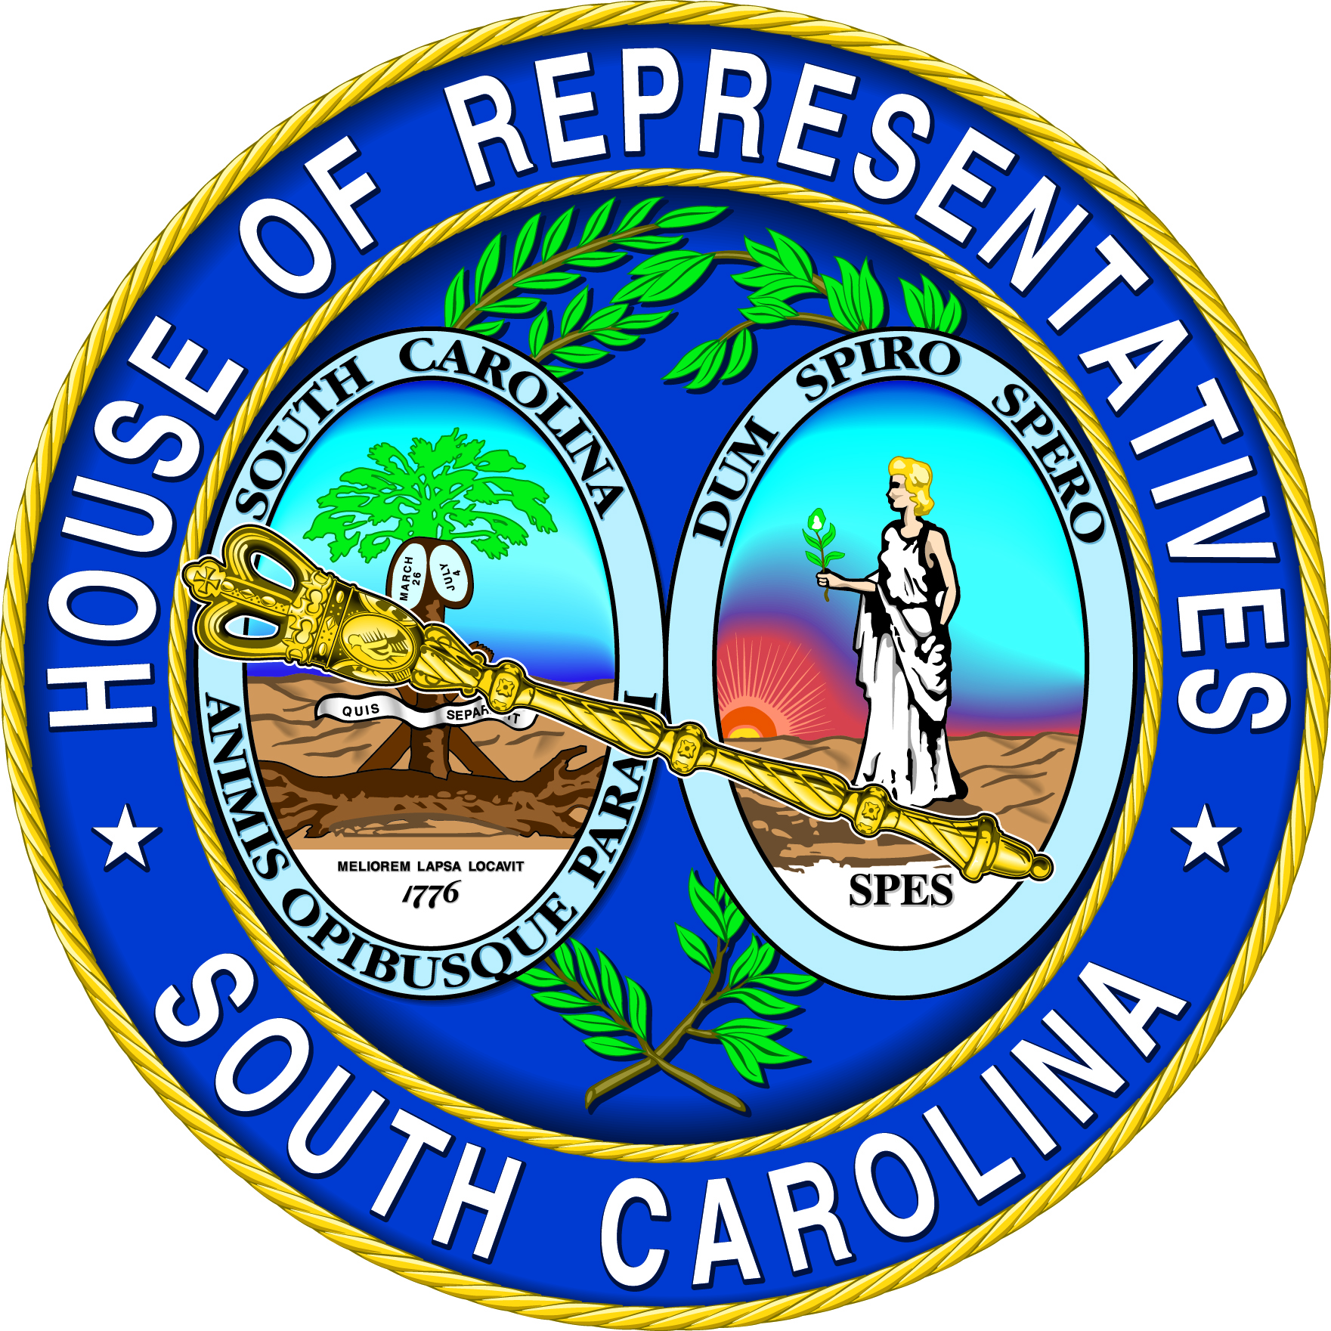 | Rep. Rosalyn Henderson-Myers  SC House District #31 - Spartanburg County  530-C Blatt Building  Columbia, SC 29201  803-212-6965 | 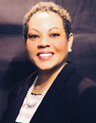

House Floor Review
February 3 - 5, 2026

H. 4760 Criminally Using Abortion-Inducing Drugs
The House has concluded its debate on, and passed, H. 4760, Criminally Using Abortion-Inducing Drugs. The Senate assigned this bill to its Medical Affairs Committee after receiving it.

This bill would add RU486, MIFEPREX regimen, mifepristone, and misoprostol to the list of Schedule IV controlled substances.

Among other things, it would create criminal penalties for possession of these controlled substances. Anyone knowingly soliciting or providing funding or assistance for unlawful delivery, dispensing, distributing, or providing these drugs to pregnant women would face criminal penalties. Anyone giving these drugs to any pregnant woman without her consent would face homicide prosecutions, but not the death penalty, for killing the fetus. Anyone administering legitimate medical treatment to a pregnant woman would not be able to be so charged.

In addition, our attorney general could seek civil forfeitures from, and injunctions against, these illegal facilitators, who would face forfeiture of any funds for their illegal activities.

However, it would specifically exclude any contraceptive use. Wholesale distributors licensed by the South Carolina Board of Pharmacy who act in compliance with applicable state and federal laws, regulations, and policies would be exempt from the provisions of this pending legislation. This exemption would extend to their lawful possession, storage, transfer, or distribution of these drugs. In its current version, it would take effect ninety days after the governor signs it.

S. 415 Kinship Foster Care Parent Qualifications
The House amended, passed, and returned to the Senate S. 415 Kinship Foster Care Parent Qualifications. Eighteen-year-olds could qualify to be kinship foster parents under the provisions contained in this pending legislation. As amended, this bill would require compliance with the Federal Multiethnic Placement Act when the state licenses these fictive kin foster parents.

S. 405 Homicide By Child Abuse Age Modifications
The House has amended and passed S. 405 Homicide by Child Abuse Age Modifications. It has been returned to the Senate for further deliberations.

This bill would address an identified prosecutable age gap under our existing state criminal law by raising the maximum age of minors considered to have been killed by child abuse from eleven years old up to less than sixteen years old, once enacted. As amended, this bill would allow these charges to be made when an offense is committed against a special needs person, with intellectual or related disabilities, up to their eighteenth birthday.

H. 4720 Second Pretrial Intervention Participation Opportunities
H. 4720 has been given third reading and has been sent to the Senate for its deliberations. They have assigned it to their Judiciary Committee. Defendants accused of nonviolent crimes could apply for pretrial intervention program participation a second time. Applicants would have to have successfully completed their prior pretrial intervention [PTI] program participation at least twenty years prior, should this legislative effort be successful. Circuit solicitors would retain their authority to decide whether these applicants will be admitted to PTI for a second time.

H. 3551 Poll Worker Pay
The House approved and sent the Senate H. 3551, a bill addressing poll worker pay. The legislation revises income tax provisions relating to the computation of South Carolina Gross Income to exclude certain amounts paid to managers and clerks of elections. The legislation also provides that certain amounts paid to managers and clerks of elections are not considered earnable compensation under South Carolina Retirement System provisions.

If you have a comment or opinion concerning the issues discussed in this report, or if I may be of assistance to you at any time, please feel free to call your legislative office in Columbia (803-212-6965), my office in Spartanburg (864-435-9727) or write P. O. Box 1311, Spartanburg, SC 29304. If you would like any additional information on these bills, or any other legislation under consideration by the General Assembly, feel free to visit our website at www.scstatehouse.gov. Thank you for the opportunity to serve you in the House of Representatives.

RHM/dkh/Henderson-Myers-2026feb6

