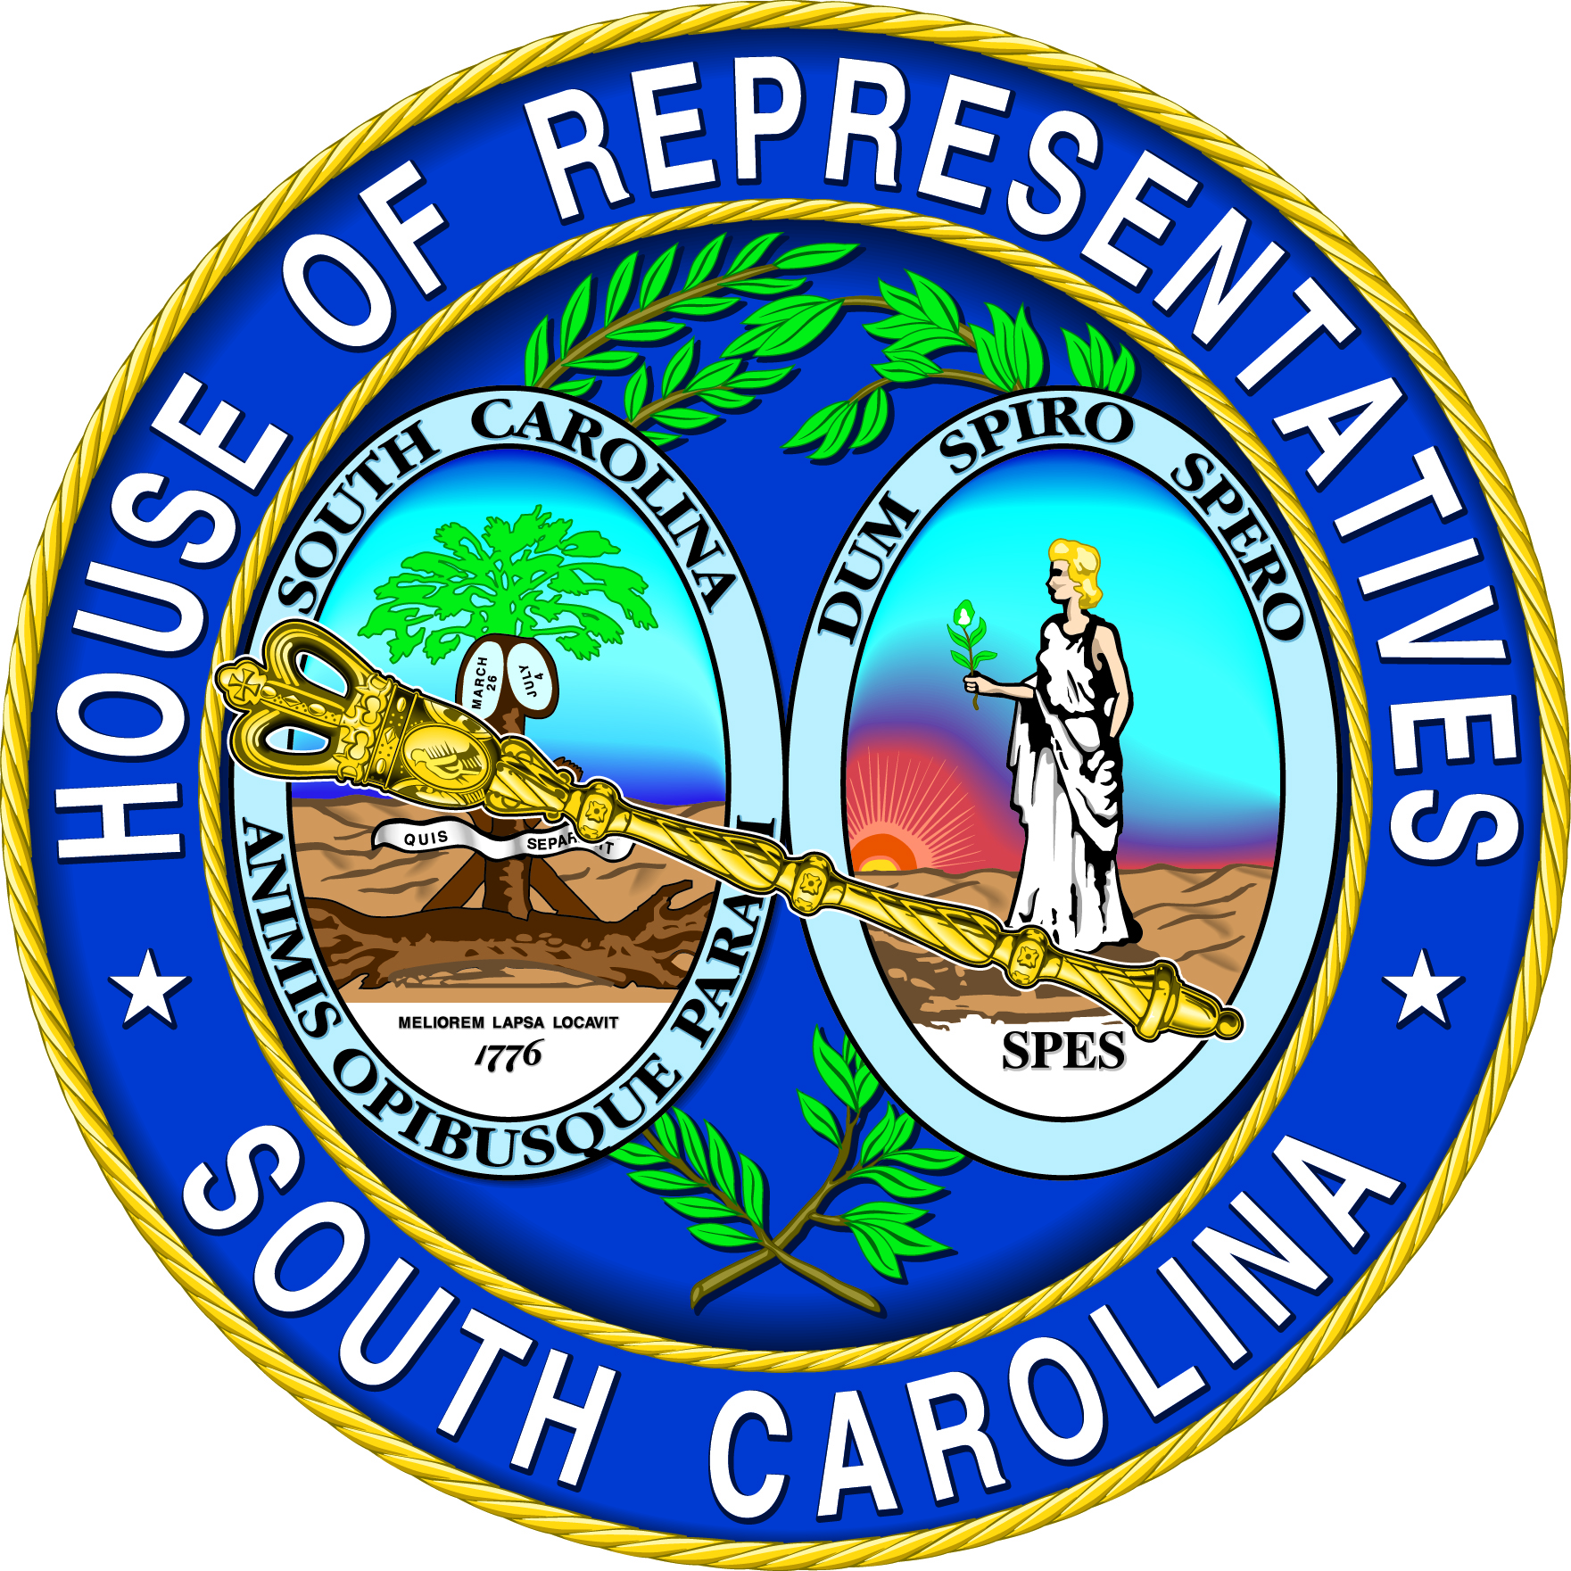 | Rep. Rosalyn Henderson-Myers  SC House District #31 - Spartanburg County  530-C Blatt Building  Columbia, SC 29201  803-212-6965 | 

House Floor Review
February 17 - 19, 2026

H. 4813 Magistrates Court Fees and Assessment Increases
The House has passed, and sent to the Senate, H. 4813, Magistrates Court Fees and Assessment Increases. The Senate has referred this bill to its Judiciary Committee. In its current proposed version, various magistrate court fees, costs, and filing fees, would be increased under the provisions contained in this bill. These increases include, but are not limited to, filing bonds in civil cases to ten dollars, issuing a summons and complaint to sixty-five dollars, twenty dollars for executions, forty dollars in eviction actions, and to ten dollars for issuing other documents. All of these collected fees and costs would be designated for magistrate court operations.

S. 415 Kinship Foster Care Parent Qualifications
The Senate has concurred in House amendments to S. 415 Kinship Foster Care Parent Qualifications. It has been enrolled for ratification. Under this current version, eighteen-year-olds could qualify to be kinship foster parents under the provisions in this pending legislation. As amended, this bill would affirm compliance with the Federal Multiethnic Placement Act when licensing these fictive kin foster parents.

S. 477 Self-Administered Hormonal Contraceptives Protocols
The House has amended, and returned to the Senate, S. 477 Self-Administered Hormonal Contraceptives Protocols. Under the provisions of this pending legislation, and to clarify implementation of the provisions of the 2022 Pharmacy Act, the State Board of Medical Examiners would be responsible for setting out protocols for dispensing self-administered orally taken, or injected, hormonal contraceptives either with or without a standing order for them being in place. This protocol would be the case for anyone 18 years or older, or who is emancipated and had a previous prescription issued to them.

H. 5096 Ban on Artificial or Cell-Cultured Food Products
The House gave second reading with unanimous consent for third reading on next legislative day to H. 5096, legislation dealing with a ban on artificial or cell-cultured food products. In a continued effort to ensure food safety and consumer transparency, this bill prohibits the manufacture, sale, or distribution of artificial or cell-cultivated food products. The legislation also applies to plant based meat substitutes. The bill adds as well as increases additional penalties for violations, including authorizing the Department of Agriculture to revoke or suspend the business license of a food establishment that violates this provision.

H. 5097 Roadside Markets
The House gave second reading with unanimous consent for third reading on next legislative day to H. 5097, a bill that allows certain roadside markets operated by farmers who sell the public products they produce and who are not considered commercial operations. For purposes of this provision, “roadside markets” are defined as markets located near a roadway on farm property that is owned or leased and controlled by the farmer. This legislation does not include multi-vendor farmers’ markets or alike outlets. These roadside markets are exempt from certain local and state regulatory requirements. Local governments shall not be held liable for matters arising under these exemptions outlined in the bill.

S. 383 State Migratory Bird Act
The House gave S. 383, the “Prothonotary Warbler Recognition Act,” bill second reading with unanimous consent for third reading on next legislative day. The bill designates the Prothonotary Warbler as the official State Migratory Bird of South Carolina.

H. 4757 Parental Rights Act
The House amended, gave third reading and sent to the Senate H. 4757, a bill that establishes the “Parental Rights Act.” Among many things, the legislation affirms and enumerates the fundamental rights of parents to direct the upbringing, education, healthcare and general welfare of their children. The bill requires the State Board of Education to adopt minimum standards to implement parental rights, including parental rights policies for local education agencies (LEAs). The State Board of Education must also adopt a model parental rights policy that complies with these minimum standards. Each LEA governing board, in consultation with parents, teachers, and administrators, must develop and adopt a parental rights policy to promote the involvement of parents of children enrolled in the LEA.

The bill removes the statutory authority that allowed minors who are at least sixteen years old to consent independently to health services. As a result, consent from a parent or legal guardian will be required unless another provision of law provides otherwise or until a child reaches the age of 18. In addition, the bill removes existing laws that allow certain medical services to be provided to minors without parental permission and removes language that made a minor’s consent legally binding after they become an adult.

The bill also establishes administrative procedures for the investigation and resolution of alleged violations, as well as private causes of action upon exhaustion of administrative remedies. Overall, the bill provides for parental rights if there is a violation as well as provides for teacher coverage of protection.

H. 3477 Revising Provisions for the Maximum Unemployment Insurance Benefits
The House amended, approved, and sent the Senate H. 3477, a bill revising provisions for the maximum unemployment insurance benefits allowed in a single year so that the duration of these jobless benefits varies based on seasonally adjusted statewide unemployment rates. The legislation replaces current provisions for the maximum duration of benefits, which is set without regard to economic conditions, with a schedule that allows for the collection of the full twenty weeks of unemployment benefits when South Carolina is experiencing relatively high levels of unemployment and fewer weeks of benefits when the state’s economy is robust enough to send the unemployment rate into decline. Under the schedule established by the legislation, the maximum duration of unemployment benefits is set at the full twenty weeks when the state’s seasonally adjusted unemployment rate rises above 9 per cent. A week of benefits is subtracted from the maximum each time a benchmark for a successively lower rate of unemployment is reached, until the maximum duration is set at twelve weeks of benefits when the state is experiencing a seasonally adjusted unemployment rate of no more than 5.5 per cent. The Department of Employment and Workforce is charged with promulgating regulations to ensure compliance with job search requirements and to prevent fraud. These regulations may include verification of attendance at job interviews. The legislation also includes authority for the Department of Employment and Workforce to deliver notifications and reports electronically along with other statutory updates and revisions recommended by the House Government Efficiency and Legislative Oversight Committee following its review of DEW.

If you have a comment or opinion concerning the issues discussed in this report, or if I may be of assistance to you at any time, please feel free to call your legislative office in Columbia (803-212-6965), my office in Spartanburg (864-435-9727) or write P. O. Box 1311, Spartanburg, SC 29304. If you would like any additional information on these bills, or any other legislation under consideration by the General Assembly, feel free to visit our website at www.scstatehouse.gov. Thank you for the opportunity to serve you in the House of Representatives.

RHM/dkh/Henderson-Myers-2026feb20

